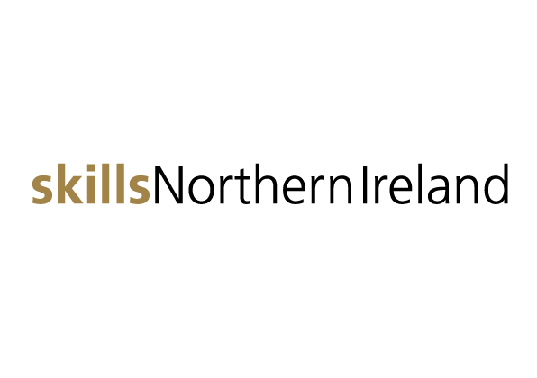 press release
19 November 2019
Embargoed until 00.01 on 20 November 2019
Skills Northern Ireland opens its doors to inspire young people about future careers
Research from a survey of 920 young people from across Northern Ireland shows only 15% are thinking about going into apprenticeships or employment, while the remainder are opting for further education or university life.
36% turn to their parents for careers advice, many of whom are ill-equipped to provide impartial and accurate labour market information. 35% of young people are concerned there may not be enough jobs available to them when they leave school.
32% of young people do not think they will have enough experience to convince an employer to give them a job. More encounters with employers are needed from an early age.
How can we help young people to make good choices and inspire them to see a bright future ahead in Northern Ireland?
One of the most significant contributions businesses can make to support young people in schools and colleges is send volunteers from industry into the classroom to work on projects, talk about their work and help young people to see the relevance of their learning to the world of work.
With this in mind, the doors will open today at the TEC Belfast on Northern Ireland’s biggest careers fair - Skills Northern Ireland.
Aimed at 14-19 years olds, parents, teachers and influencers, the two-day exhibition (20 & 21 November) will see businesses from across Northern Ireland gather to help enlighten them about jobs and career choices, apprenticeships, courses, growing industry sectors and training opportunities.
The event will launch with a Business Breakfast at Belfast Met’s Titanic Quarter Campus, where Dr Deirdre Hughes OBE, Chair of Skills Northern Ireland will present the results from the Young People’s Career, Choice and Future Preferences Survey.
“It’s encouraging to find 60% of young people had an idea about the career they would like to follow after completing their education. 71% were confident about securing their ideal job – this demonstrates optimism and hope for their future lives. However, there some who are genuinely concerned about not having the skills, qualifications or experience to get a foothold into work. The numbers considering apprenticeships and employment is indicative of a potential skills shortage in the future.”
Speakers will include James Hutchinson (Department of Education), Mark Magill (Ulster University), Helen Brady (City & Guilds), Olly Newton (Edge Foundation) and Paula Leatham (NIE Networks). The meeting will also include an expert panel session and Q&A.
Gabrielle McEvans, Project Manager of Skills Northern Ireland explained: “This is the fourth year of the event. Following its massive success last year, we’re bringing together more than 70 organisations and expecting over 7,000 pre-booked visitors over the two days. There’s a huge appetite for it, both from the students’ perspective and from the employers’ point of view.
“Skills Northern Ireland is the ideal platform for companies wishing to target young people, whether that is to promote courses, apprenticeships, work experience or job opportunities. It’s also an opportunity to engage with the teachers and careers advisers who influence the career decisions of our future generation.
“It’s an important showcase of a new approach to joined up thinking between skills training and workforce planning to ensure companies in the region have the appropriately qualified staff they’ll need in years to come.”
Many of the employers attending the event see the benefits in terms of attracting the required numbers of local youngsters to take up positions as highly qualified apprentices or graduate programmes.
Paula Leathem, Senior HR Business Partner at NIE Networks, the leading sponsor of this year’s event, is encouraging young people, teachers and parents to come along. “The talent pool in Northern Ireland is shrinking and events such as Skills Northern Ireland are crucial to helping address that issue and close the skills gap by showcasing what Northern Ireland employers can offer young people. We are trying to encourage more young people to choose STEM subjects and a technical or engineering pathway.
“In addition to a variety of apprenticeship opportunities we also have our own bespoke undergraduate scholarship program which we deliver through Queen’s University Belfast. Professional support roles are also available across HR, finance, communications and customer service, so there really is a career for everyone. I cannot encourage students and parents enough to come along to Skills Northern Ireland and see what doors of opportunity we can open for them.”
Many employers are seeing the advantages – and school leavers are seeing the appeal – of a rapidly expanding range of earn-while-you-learn apprenticeship opportunities in new areas including accountancy, software engineering and electrical engineering. Gabrielle McEvans said: “While this is an event geared for students, we would strongly encourage teachers, and in particular careers advisors, to come and make all the contacts they possibly can. By supporting closer working between education and business, we believe Skills Northern Ireland can play a major role in shaping the local economy.” Skills NI takes place on 20th and 21st November in TEC Belfast. To find out more visit www.skillsni.co.uk
Ends - For further information, please contact Sasha McKnight or Laura Tweed at ASG & Partners on 028 9080 2000 or sasha@asgandpartners.com / laura@asgandpartners.com

